PROJECT TITLE

AI Impact on Workforce Analysis Using Excel and Power BI

1. Project Overview and Objective
This project focuses on cleaning, transforming, and analysing workforce data to understand the impact of Artificial Intelligence (AI) adoption on employee performance, job satisfaction, automation risk, and attrition. The dataset was processed using Microsoft Excel and visualized using Power BI to generate meaningful business insights.

Objective
The main objective of this project is to demonstrate data pre-processing techniques using Excel and create an interactive Power BI dashboard to analyse workforce trends, AI adoption levels, employee performance, and organizational outcomes for better decision-making.

2. Data Sources
Source Description: AI Impact on Workforce Dataset
Timeline: 2020–2025
Domain: Human Resource Analytics / Workforce Analytics / Artificial Intelligence
Dataset Type: Employee and Organizational Data

3. Problem Statement
To analyse the impact of Artificial Intelligence adoption on employee performance, job satisfaction, automation risk, and attrition in order to support workforce planning and organizational decision-making.
Specific objectives include:
- Identifying departments with higher AI adoption levels.
- Analysing the relationship between training hours and employee performance.
- Evaluating automation risk across employees.
- Understanding factors influencing employee attrition.
- Assessing workforce satisfaction and productivity.

4. Attribute (Column / Feature) Details
Attribute Name | Data Type | Description
Employee_ID | Integer | Unique employee identifier
Age | Integer | Employee age
Gender | Categorical | Gender of employee
Department | Categorical | Department name
Job_Role | Text | Employee job role
City | Text | Employee city
State | Text | Employee state
Salary | Numeric | Employee salary
Experience_Years | Numeric | Years of experience
AI_Adoption_Level | Categorical | AI adoption level
Automation_Risk | Categorical | Risk of automation
Training_Hours | Numeric | Employee training hours
Performance_Score | Numeric | Performance evaluation score
Job_Satisfaction | Categorical | Satisfaction level
Attrition | Categorical | Employee attrition status
Project_Count | Numeric | Number of projects handled

5. Tools & Technologies

Microsoft Excel
- Data Cleaning
- Data Transformation
- Missing Value Handling
- Filtering & Sorting
- Pivot Tables

Power BI
- Data Modelling
- DAX Calculations
- Dashboard Development
- Interactive Visualizations
- KPI Analysis

6. Data Pre-Processing (Excel)

Tasks Performed

Data Cleaning & Transformation
- Removed duplicate records.
- Handled missing values using Median and Mode methods.
- Standardized text formats.
- Corrected inconsistent values.
- Verified data types.

Filtering & Sorting
- Sorted employee records by department, salary, and performance.
- Applied filters to identify relevant employee groups.

Pivot Tables
Created Pivot Tables for:
- Employee count by department.
- AI adoption distribution.
- Average salary by department.
- Attrition analysis.

Fact and Dimension Tables
Fact Table:
- Employee_Fact
Dimension Tables:
- Department_Dim
- Location_Dim
- AI_Adoption_Dim
- Satisfaction_Dim

7. Data Modelling and DAX (Power BI)

Data Model
Relationships were established between Fact and Dimension tables using Employee_ID and related lookup keys.

DAX Measures
Total Employees
COUNT(Employee[Employee_ID])
Average Salary
AVERAGE(Employee[Salary])
Average Performance Score
AVERAGE(Employee[Performance_Score])
Attrition Count
CALCULATE(COUNT(Employee[Employee_ID]), Employee[Attrition]="Yes")
Average Training Hours
AVERAGE(Employee[Training_Hours])

Screenshot
(Insert Data Model Screenshot Here)

8. Analysis and Visualizations (Power BI)

Dashboard Features
- KPI Cards
  - Total Employees
  - Average Salary
  - Average Performance Score
  - Attrition Count
- Bar Chart
  - Employees by Department
- Pie Chart
  - AI Adoption Level Distribution
- Matrix
  - Average Salary by Department
- Matrix
  - Total project
- Donut Chart
  - Attrition Analysis
- Bar Chart
  - Automation Risk Distribution
- Column Chart
  - Job Satisfaction Analysis

Interactive Features
- Department Slicer
- Gender Slicer
- State Slicer

Dashboard Screenshot
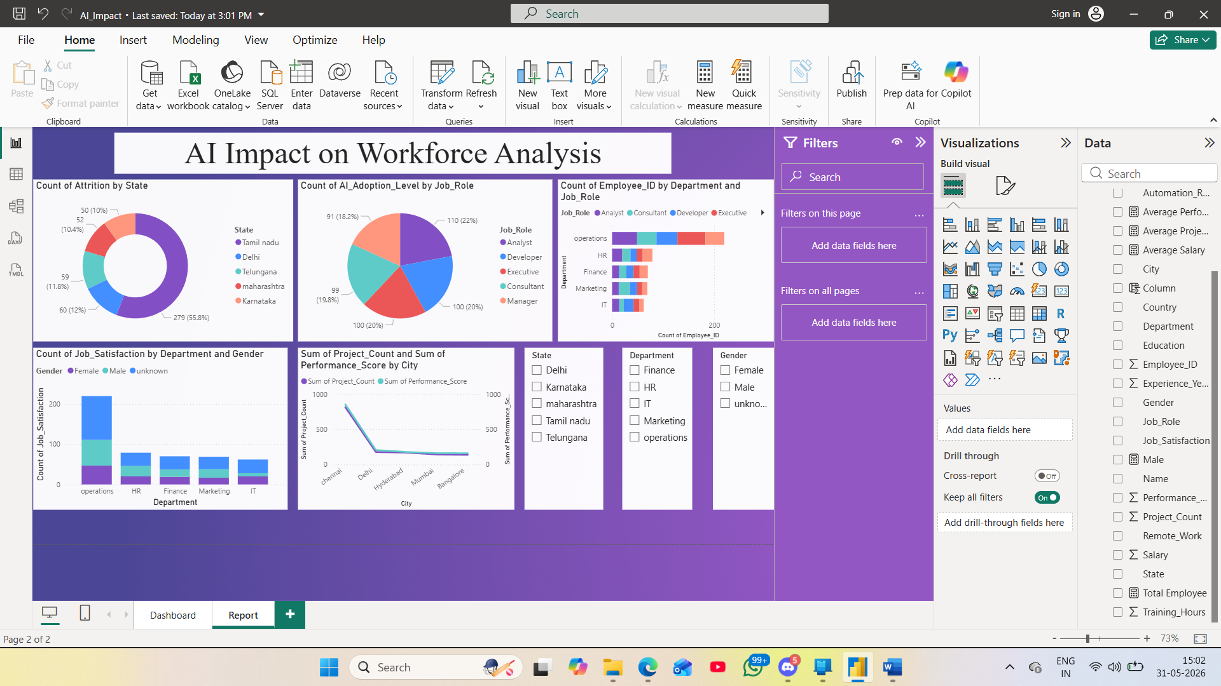

9. Insights & Conclusions

Descriptive Analysis
- Workforce is distributed across multiple departments.
- AI adoption levels vary among employees.
- Average salary differs significantly between departments.

Diagnostic Analysis
- Employees with higher training hours generally achieve better performance scores.
- Departments with lower satisfaction levels show higher attrition rates.

Predictive Analysis
- Employees with low satisfaction and high automation risk are more likely to leave the organization.
- Increased AI adoption may improve operational efficiency.

Prescriptive Analysis
- Increase employee training programs.
- Improve employee engagement initiatives.
- Develop reskilling programs for high-risk employees.
- Monitor attrition trends continuously.

10. Conclusion
The integration of Excel and Power BI proved highly effective for end-to-end workforce analytics. Data cleaning and transformation improved data quality, while Power BI dashboards enabled clear visualization of workforce trends. The analysis highlighted the impact of AI adoption on employee performance, satisfaction, automation risk, and attrition, helping organizations make informed strategic decisions.

